**Lab 15**

**Name :-** Aryan Dilipbhai Langhanoja

**Date :-** 12-09-2023

**Enrollment No :-** 92200133030

**CO1: To write, test, and debug simple Python programs**

**CO2: To implement Python programs with conditional, loops and functions**

**Task 1:- Using Numpy Library generate random values to be passed as input to the graph.**

**Python Code:**

num = 100

x = np.random.random(num)

y = np.random.random(num)

follow = G.Scatter(

x = x ,

y = y ,

mode = 'markers'

)

output1 = [follow]

plt.offline.plot(output1,filename='Task-1.html',auto_open=True)

**Output:**

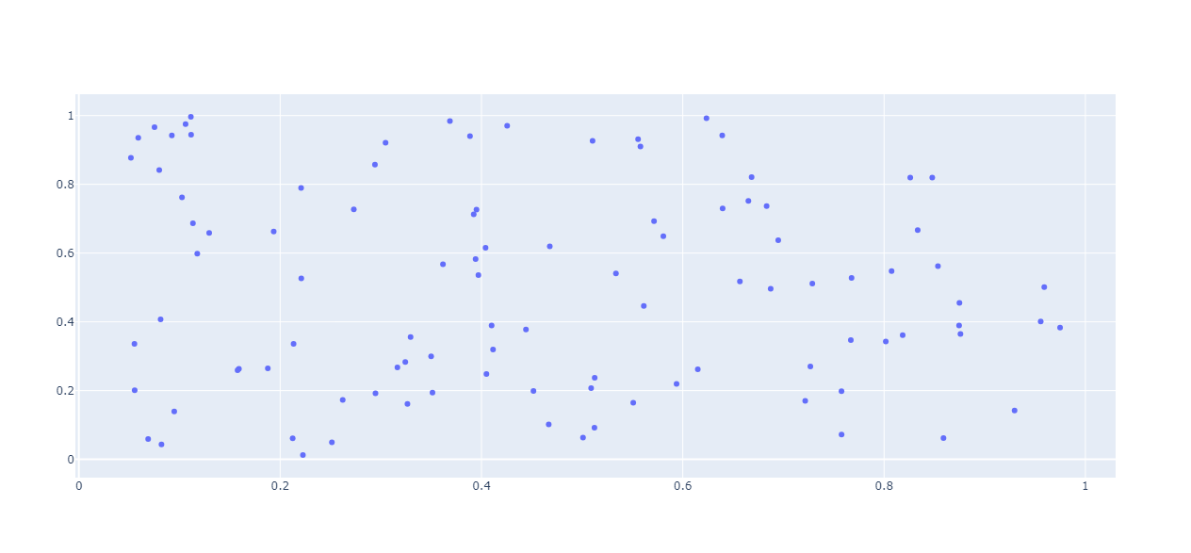

**Task 2:- Represent Data Using Combination of line**

**Python Code:**

N = 20

X = np.linspace(0,1,N)

y0 = np.random.randn(N) - 10

y1 = np.random.randn(N)

y2 = np.random.randn(N) + 10

plot0 = G.Scatter(

x = x,

y = y0,

mode = 'markers'

)

plot1 = G.Scatter(

x = x,

y = y1 ,

mode = 'lines + markers'

)

plot2 = G.Scatter(

x = x ,

y = y2 ,

mode = 'lines'

)

output2 = [plot0,plot1,plot2]

plt.offline.plot(output2,filename='Task-2.html',auto_open=True)

**Output:**

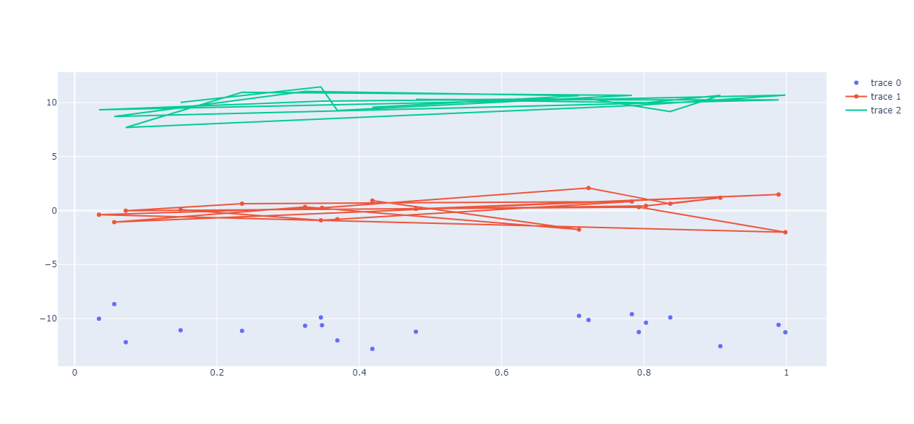

**Task 3:- Box Plot**

**Python Code:**

a = np.random.rand(100) - 10

b = np.random.rand(100) + 10

output4 = G.Figure()

output4.add_trace(G.Box(y = a))

output4.add_trace(G.Box(y = b))

plt.offline.plot(output4,filename='Task-4.html',auto_open=True)

**Output:**

